Directorate of Sports & Youth Services
Aizawl, Mizoram

PERSONAL BIO-DATA & PERFROMANCES

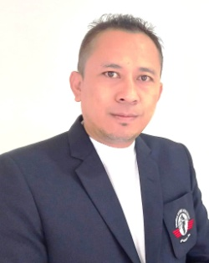
(1) NAME :ROZAMLIANA

(2) NICK NAME :RZA

(3) S/O :LALREMRUATA(L)

(4) DESIGNATION :COACH GRADE – I

(5) ADDRESS :H.NO. DZ-15/1, ZAMPUIMANGA SECTION
DINTHAR, AIZAWL, MIZORAM – 796001__

(6) EMAIL :rozamliana@gmail.com

(7) Contact No : 7795912211

ACHIEVEMENT AND ACTIVITIES AS A PLAYER:

(1) Diploma in Sports Coaching (BOXING), NS,NIS: 2008-09 Topper in Boxing discipline

(2) Post Graduate Diploma in Sports Management

(3) Represented Air Force in YMCA National: 2 times

(4) Inter Services Championship: Represented Air Force 6 Times

(5) Air Force Boxing Championship: 7 times Gold

(6) Adjudge Best Boxer of Indian Air Force: in the year 2000

ACHIEVEMENT AND ACTIVITIES AS A COACH:

(1) Maintenance Command Boxing Coach, IAF: 2009 to 2010

(2) Training Command Boxing Coach, IAF: 2010 to 2013

(3) Western Air Command Boxing Coach, IAF: 2013 to 2015

(4) Eastern Air Command Boxing Coach, IAF: 2015 to 2017

(5) Mizoram Coach at 4th Junior National Boxing Championship: 2021

(6) Mizoram Boxing Coach at 2nd North East Olympic Games: 2022

(7) Mizoram Coach at Youth Men National Boxing Championship: 2023

(8) Mizoram Coach at 5th Junior National Boxing Championship: 2023

(9) Mizoram Boxing Coach at 37th National Games: 2023

