File no.D.28012/4/2020-DTE(SYS)
SPORTS AND YOUTH SERVICES DEPARTMENT
GOVERNMENT OF MIZORAM
New capital Complex (MINECO), Khatla, Aizawl, Mizoram-796001

Subject - Notice inviting applications for appointment of PHYSIOTHERAPIST grade I & II on contract basis for Khelo India State Centres of Excellence, Aizawl, Mizoram.
Sports and Youth Services department, Government of Mizoram &SAI is setting up new sports Academies at Rajiv Gandhi Stadium , Mualpui, Aizawl to nurture the best talent of the country identified through Khelo India Talent Identification. The Academies will be equipped with world class infrastructure and coaching facilities with adequate scientific backup with focused on participation in world sports tournament & Olympics.

In order to lead these High-performance Academies Sports and Youth Services department, Government of Mizoram & Sports Authority of India (SAI), invites applications from eligible citizens of India for filling up the post of one PHYSIOTHERAPIST grade I & II ( one post each) for Khelo India State Centres of Excellence, Aizawl (Rajiv Gandhi Stadium).The last date for the submission of application is 7th May. 2021.

Sd-
H.LALENGMAWIA
Secretary
Sports and Youth Services Department
Government of Mizoram

PHYSIOTHERAPIST
(Specific requirements, shortlisting and interview information)

- ESSENTIAL EDUCATIONAL QUALIFICATIONS.

Masters in Physiotherapy from any recognized Indian or Foreign University.

- ESSENTIAL WORK EXPERIENCE.

Minimum 3 years of work experience as Physiotherapist.

- CRITERIA FOR SHORTLISTING OF CANDIDATES FOR INTERVIEW.

Short listing of candidates to provide an optimum ratio for the interview will be carried outon following basis:

CATEGORIES FOR EVALUATION | MAX MARKS | SCORING OF MARKS
Total Work experience as Physiotherapist | 20 | 2 marks for every completed 1 year of work experience as physiotherapistwill be awarded, upto a maximum of 20 marks
Work experience in sports | 30 | 3 markswill be awardedfor every completed 1 year of work experience as Sports Physiotherapist at a recognized State level / National level sports organization(Govt. or Private)/ teams/playersupto a maximum of 30 marks
Marks obtained in Master’s degree | 20 | Percentage of marks >50%-- 60% --10marks  Percentage of marks >60%- 70% --15marks  Percentage of marks >70% --20marks
Masters in Physiotherapy  (Specialisation) | 30 | Sports Science  Musculo - Skeleton Science  Orthopedics  Health promotion in disability rehabilitation | 30  15  15  15

- INTERVIEW PROCESS

The Candidates will be assessed on the following:

CATEGORIES FOR EVALUATION | MAXIMUM MARKS
Domain Expertise | 30
Practical knowledge | 30
Aptitude for working in a sports organization | 10
Knowledge related to recent advancements in the relevant discipline. | 10
Soft skills | 10
Knowledge in allied sports science discipline | 10

NOTE:

THE ABOVE MENTIONED SHORT LISTING CRITERIA WILL BE USED FOR CALLING THE CANDIDATES TO APPEAR IN THE INTERVIEW.

THE FINAL MERIT WILL BE BASED ON THE SCORE OBTAINED IN THE INTERVIEW ONLY.

THE CANDIDATE MUST PRODUCE ALL THE ORIGINAL DOCUMENTS, AT THE TIME OF PHYSICAL JOINING OTHERWISE THE CANDIDATURE WILL BE CANCELLED.

- DOCUMENTS REQUIRED:

Self attested scanned copy of original documents of the following be uploaded:

- PHYSIOTHERAPIST

- DEGREE AND MARKSHEET:

The certificate uploaded must be one issued by the Competent Authority (i.e. University or other examining body) awarding the particular qualification.

Masters in Physiotherapy from a recognized Indian or Foreign University.

- WORK EXPERIENCE

Documents claiming work experience must clearly mention the following

  - Name of the establishment
  - Signature competent authority/issuing authority clearly stating their position of authority in the organization.
  - Duration of work experience.
d. The field in which the candidate has workedor the post held in the establishment.

- OTHER DOCUMENTS:

- Proof of Date ofbirth: Aadhar Card/10th class mark sheet/12th class mark sheet.
- Recent passport size color photograph.
- Scanned copy of No Objection Certificate from their present employer, in case working in Central/ State Government/ Autonomous Organizations on regular basis.

GENERAL INSTRUCTIONS

(All the instructions given below must be strictly followed or else the application
is liable to be rejected)

- WHO CAN APPLY: Applications are invited only from candidates who fulfill eligibility criteria of essential educational qualification and essential work experience as mentioned in above sports science discipline.These are minimum eligibility criteria for application for above posts.

- After the initial registration is completed online, the candidate must upload the following documents in the below mentioned order. Self attested documents in PDF format are to be uploaded. (See sample document in the end)

The order of documents is as follows:
- Candidate details: Name
              - Application No
              - Contact No
              - Address
              - Email id
- Document for DOB:
- Online application printout.
- Mark sheet of postgraduate degree.
- Mark sheet of graduation degree.
- Degree certificate of post-graduation course.
- Degree certificate of graduation course.
- Work experience if any.
- Skill certification (wherever applicable) if any.
- Documents supporting sports achievement if any.

- The responsibility of ensuring genuineness of the certificate lies completely on the candidate by self-attestation. SYS Department Government of Mizoram reserves the right to discard experience certificates which do not provide correct details as asked above. Website links could be provided to ascertain genuineness.

- Any experience claimed during the course of completion of the degree will not be counted. Any experience which is not relevant to the above discipline /fields will not be counted.

- Candidates will be called for the interview on the criteria as mentioned above. Hence mere fulfillment of eligibility criteria does not entail that candidate will be called for the interview.

- The Candidates should note that their candidature at all the stages will be purely provisional, subject to their satisfying the prescribed eligibility conditions. If on verification at any stage before or after Interview, it is found that they do not fulfill any of the eligibility conditions; their candidature will be cancelled by the SYS Department Government of Mizoram.

- NOTE: SELECTED CANDIDATES WILL BE REQUIRED TO PRODUCE THE ORIGINALS OF THE CERTIFICATES MENTIONED ABOVE PHYSICALLY AT THE TIME OF JOINING. FAILURE TO SUBMIT THE REQUIRED CERTIFICATES IN ORIGINAL AT THE TIME OF PHYSICAL JOINING WILL LEAD TO CANCELLATION OF CANDIDATURE.

- Terms & Conditions for contractual engagement:

      - Tenure: Initial contractual engagement will be for a period of fouryears which could be further extended for a maximum period of five years on the basis ofsatisfactory performance.
      - Age Limit: - The maximum age shall not be more than 45 years on the last date of receipt of applications.
The date of birth, accepted by the SYS Department Government of Mizoram is that entered in the Matriculation or Secondary School Leaving Certificate or in a certificate recognized by an Indian University as equivalent to Matriculation or in an extract from a Register of Matriculates maintained by a University which extract must be certified by the proper authority of the University or in the Higher Secondary or an equivalent examination certificate. No other document relating to age like horoscopes, affidavits, birth extracts from Municipal Corporation, Service records and the like will be accepted. The expression Matriculation/Higher Secondary Examination Certificate in this part of the Instruction include the alternative certificates mentioned above.

      - Remuneration: - Monthly remuneration will be decided on the basis of expertise and performance of the candidates in the interview and on the recommendation of the Selection Board.
Based on the recommendation: The candidates will be placed in different grades (Grade I and Grade II)

PHYSIOTHERAPIST GRADE I---Rs. 40,000—60,000/-
PHYSIOTHERAPIST GRADE II---Rs. 60,000---80,000/-

      - Tax Deduction at source: - The income tax or any other tax liable to be deducted, as per the prevailing rules will be deducted at source before effecting the payment, for which the SYS Department Government of Mizoram will issue TDS certificates/ Service Tax, as applicable.

      - Other Allowances: - No TA /DA shall be admissible for joining the assignment or on its completion. No other facilities like DA, Accommodation, Residential Phone, Conveyance /Transport, Personal Staff, Medical reimbursement, HRA, and LTC etc. would be admissible to them.

      - Extension: - Performance of the person would be continuously reviewed and their extension will be considered on the basis of periodic review /requirement.

      - Leave: - Personnel will be entitled for 30 days leave in a calendar year on pro- rata basis. Employee shall not draw any remuneration in case of his/her absence beyond 30 days in a year. Also any un-availed leave in a calendar year will lapse and will not be carried forward to the next calendar year.

How to Apply: - : Eligible candidate shall submit their Application in the format given at Annexure II, by post and email, on or before ______march 2021, 4 PM at following address:-

Directorate of Sports and Youth Services, Government of Mizoram
New Capital Complex (MINECO), Khatla, Aizawl, Mizoram By email- dsysmizoram@gamil.com
- Applications received through any other modewould notbe accepted and summarilyrejected.Beforeregistering/submitting applications on the website the candidates should possess avalid E-mail ID. The e-mail ID entered in the online application form should remain active until the recruitment process is completed. No change in the e-mail ID will be entertained.

- Decision of SYS Department Government of Mizoram in all matters regarding eligibility, selection and posting would be final and binding on all candidates. No representation or correspondence will be entertained by SYS Department Government of Mizoram in this regard.

- SYS Department Government of Mizoram reserves the right to modify/alter/restrict/enlarge/cancel the recruitment process, if need so arises without issuing any further notice or assigning any further notice/any reasons thereafter. The decision of the SYS Department Government of Mizoram will be final and no appeal will be entertained against this issue.

- In case of any dispute, jurisdiction of Court at Mizoram only will be applicable.

- Please do visit your email account regularly for further updates.

- Further notifications/corrigendum in this regard, if any, will be put up on SYS Department Government of Mizoram only( www.sys.mizoram.gov.in ).

- In case of any dispute, English version of the Employment notice will be treated as valid.

CANVASSING IN ANY FORM WILL BE ADISQUALIFICATION.

Designation | Job Responsibilities
Physiotherapist | - Planning and development of physiotherapy protocols.  - Maintain the record of present and past injuries for the athletes in the camp/center  - Management of hydrotherapy, sauna/steam bath and other facilities available to the center.  - Evolve injury prevention strategy for the athlete in consultation with the team doctor  - Injury management in field.  - Shall be responsible for day to day injury prevention and rehabilitation of the athletes  - Assist in injury prevention strategy  - Any other duties assigned by High Performance Director, Sports Science Head and Regional Head and Director SYS department Government of Mizoram.

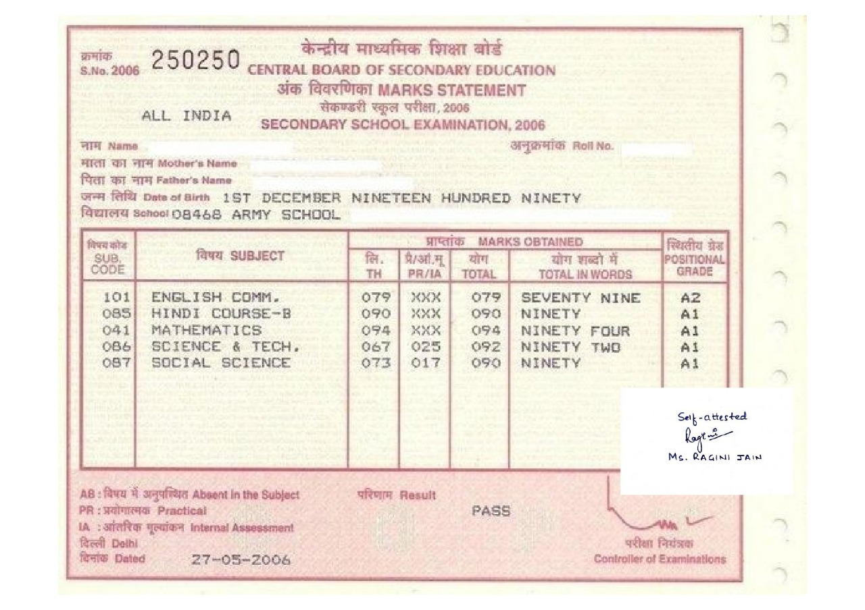

SAMPLE DOCUMENT DEMONSTRATING HOE THE CERTIFICATES ARE TO BE ATTESTED AND SCANNED AND COMPILED IN THE FORMAT REQUIRED.

APPLICATION FORM:
APPLICATION FORM FOR THE POST OF PHYSIOTHERAPIST AND STRENGTH & CONDITIONING EXPERT
- Full Name in Capital Letters (as per the matriculation certificate):
- Gender:
- Date of Birth (as per the matriculation certificate):
- Father’s Name (as per the matriculation certificate):
- Nationality:
- Permanent Address:
- Address for Communication:
- Mobile number and Email ID (a valid and functional email ID to be provided):
- Academic Qualifications:

Degree | Maximum Marks | Marks Obtained | Percentage of Marks | Name and Address of College/Institution | University | Year of Passing
Graduation (specify the discipline)
Post-Graduation(specify the specialty)

- Subjects in Graduation—
- Subjects in Post-graduation-
- Details of certification course wherever applicable—
- Details of Services rendered earlier/Experience in related field: (After the basic graduation).
Designation | Name and Address of the Organization | Duration of Tenure |  | Total Period
 |  | From | To
- Details of sports achievements- Details of participation- Name of event.
Year of participation
Position
Declaration: I solemnly declare that the above statements made by me are correct to the best of my knowledge and belief. I shall abide by the rules and regulation of SYS Department Government of Mizoram.

Name & Signature of Candidate

