File no.D.28012/4/2020-DTE(SYS)
SPORTS AND YOUTH SERVICES DEPARTMENT
GOVERNMENT OF MIZORAM
New capital Complex (MINECO), Khatla, Aizawl, Mizoram-796001

Sports and Youth Services Department, Government of Mizoram &SAI invites online application for Masseur-II /Masseuse-II on contract basis.

Sports and Youth Services Department, Government of Mizoram &SAI is setting up new sports Academies at Rajiv Gandhi Stadium , Mualpui, Aizawl to nurture the best talent of the country identified through Khelo India Talent Identification. The Academies will be equipped with world class infrastructure and coaching facilities with adequate scientific backup with focused on participation in world sports tournament & Olympics.
In order to lead these High-performance Academies Sports and Youth Services Department, Government of Mizoram & Sports Authority of India (SAI), invites applications from eligible citizens of India for filling up the post of Masseur-II /Masseuse-II for Khelo India State Centres of Excellence, Aizawl , Mizoram (at Rajiv Gandhi Stadium).The last date for the submission of application is 7th may 2021.
Vacancies

The total number of vacancies are 2(two). The initial place of posting shall be Rajiv Gandhi Stadium ,Aizawl. Mizoram. However Sports and Youth Services department, Government of Mizoram SAI reserves the right to transfer the selected candidates anywhere within Mizoram.

Sd-
H.LALENGMAWIA
Secretary
Sports and Youth Services Department
Government of Mizoram

PART - I
(EssentialRequirements, Shortlisting and Interview Information)
- ESSENTIAL REQUIREMENTS

- EDUCATIONAL QUALIFICATIONS.

Passed 10+2 from a recognized board with a certificate course/skill development program for Masseur/Masseuse/Massage Therapy/Sports Masseur/ Masseuse from a recognized institution.
- WORK EXPERIENCE.

Minimum 2 years of work experience as Masseur/ Masseuse.

- CRITERIA FOR SHORTLISTING OF CANDIDATES FOR INTERVIEW.

Of all the total applications received,short listing of candidates to provide an optimum ratio for the interview will be carried outon following basis:
CATEGORIES FOR EVALUATION | MAX MARKS | SCORING OF MARKS
Higher Educational Qualification | 10 | Diploma in massage therapy
Total Work Experience | 10 | 2 marks will be awarded for every completed 1 year of work experience as aMasseur/ Masseuseupto a maximum of 10 marks
Work Experience in Sports Establishment. | 10 | Additional 2 marks will be awarded for every completed 1 year of work experience asMasseur/ Masseuse at a recognized State / National level sports organization (Govt. or Private) working with teams/players upto a maximum of 10 marks.

- INTERVIEW PROCESS;

- The interview will be of 50 marks.

- The shortlisted candidates will be called for the interview and assessed as follows:

CATEGORIES FOR EVALUATION | MAXIMUM MARKS(100marks)
Domain Expertise & Practical Knowledge | 20
Aptitude for working in a sports organization | 10
Soft skills | 10
Knowledge in allied sports science disciplines | 10

NOTE:

OF THE TOTAL APPLICATIONS RECEIVED, CANDIDATES WILL BE SHORTLISTED FOR THE INTERVIEW BASED ON THE CRITERIA MENTIONED ABOVE.

MERIT LIST: IT IS TO BE NOTED THAT MERE QUALIFYING FOR THE INTERVIEW DOES NOT CONFIRM FINAL SELECTION. SEPARATE MERIT LIST WILL BE PREPARED PURELY ON THE BASIS OF MARKS OBTAINED BY THE CANDIDATES IN INTERVIEW.

THE CANDIDATE MUST PRODUCE ALL THE ORIGINAL DOCUMENTS; AT THE TIME OF PHYSICAL JOINING OTHERWISE THE CANDIDATURE WILL BE CANCELLED.

PART - II

GENERAL INSTRUCTIONS
(All the instructions given below must be strictly followed or else the application
is liable to be rejected)
- WHO CAN APPLY :Onlineapplications are invited from Indian citizens both male and female, who fulfillthe requisite essential requirements as listed at Para 1 above.

- HOW TO APPLY: The candidate has to apply online/Hard copy on E-Mail Id ( dsysmizoram@gmail.com )

- Applications received through any other mode would not be accepted and summarily rejected.

- Before registering /submitting applications the candidates should possess a valid E-mail ID.

- The e-mail ID entered in the application form should remain active until the recruitment process is completed. No change in the e-mail ID will be entertained.

DATE OF OPENING ONLINE REGISTRATION :(1st feb 2021)
DATE OF CLOSING ONLINE REGISTRATION :( 10th feb 2021)

NOTE :- THE PERIOD FOR INVITING APPLICATIONS SHALL BE 10 DAYS.
- ATTACHMENT OF DOCUMENTS: THE FOLLOWING ESSENTIAL CERTIFICATES/ DOCUMENTS SHOULD BE ATTESTED, SCANNED AND UPLOADED STRICTLY IN THE ORDER MENTIONED BELOW ALL COMPILED IN A SINGLE PDF FILE.

- Application form as per format enclosed.
- Document for DOB.
- 10+2 Passing Certificate.
- Diploma Course.
- Certificate Course/ Skill course for Masseur/ Masseuse.
- Work experience Certificate (Appointment/Offer letters will not be accepted) .
- No Objection Certificate from present employer, if any.

NOTE: Not attested documents will be rejected.

- CALL LETTERS FOR INTERVIEW: The Call Letters for interview shall be communicated electronically in the valid and functional email id provided by the candidatein the application form or in hard copy.

CANDIDATES SHOULD CHECK THEIR REGISTERED EMAIL REGULARLY FOR UPDATES REGARDING INTERVIEW DATES AND OTHER RELEVANT DETAILS. ANY VARIATION IN THE DETAILS PROVIDED AND DOCUMENTS SUBMITTED WILL LEAD TO REJECTION OF THE CANDIDATE.

- The responsibility of ensuring genuineness of the certificate lies completely with the candidate by self-attestation. SYS Department, Government of Mizoram/SAI reserves the right to discard experience certificates which do not provide correct details as asked above. Website links could be provided to ascertain genuineness.

- Candidates will be called for the interview based on the shortlisting criteria as mentioned above. Hence mere fulfillment of eligibility criteria does not entail that candidate will be called for the interview.

- The Candidates should note that their candidature at all the stages will be purely provisional, subject to their satisfying the prescribed eligibility conditions. If on verification at any stage before or after Interview, it is found that they do not fulfill any of the eligibility conditions; their candidature will be cancelled by the SYS Department, Government of Mizoram/SAI.

- NOTE: SELECTED CANDIDATES WILL BE REQUIRED TO PRODUCE THE ORIGINALS OF THE CERTIFICATES MENTIONED ABOVE AT THE TIME OF JOINING. FAILURE TO SUBMIT THE REQUIRED CERTIFICATES IN ORIGINAL AT THE TIME OF PHYSICAL JOINING WILL LEAD TO CANCELLATION OF CANDIDATURE.

PART – III

TERMS & CONDITIONS FOR CONTRACTUAL ENGAGEMENT:

    - Tenure:Initial contractual engagement will be for a period of four years. The tenure can be further extended by one years for a maximum period of five years on the basis of satisfactory performance. The tenure is subject to continuation of Khelo India Scheme.

    - Age Limit: The candidate must not have attained 35 years of age as on the closing date of advertisement.

    - Remuneration: - Rs. 35,000/- Per Month.

    - Tax Deduction at source: - The income tax or any other tax liable to be deducted, as per the prevailing rules will be deducted at source before effecting the payment, for which the SYS Department, Government of Mizoram/SAI will issue TDS certificates/ Service Tax, as applicable.

    - Other Allowances: - No TA /DA shall be admissible for joining the assignment or on its completion. No other facilities like DA, Accommodation, Residential Phone, Conveyance /Transport, Personal Staff, Medical reimbursement, HRA, and LTC etc. would be admissible to them.In case he/she is required to proceed outstation from the place of posting for official duty, he/she will be entitled to TA/DA as admissible for pay Level- 4 under GOI rules.

    - Extension: - Performance of the selected candidates would be continuously reviewed and their extension will be considered on the basis of periodic review /requirements.

    - Leave: - Personnel will be entitled for 30 days leave in a calendar year on pro- rata basis. Employee shall not draw any remuneration in case of his/her absence beyond 30 days in a year. Alsoany un-availed leave in a calendar year will lapse and will not be carried forward to the next calendar year.

    - Termination: - The contract can be terminated by giving a 30 days’ Notice period by either party, i.e. SYS Department, Government of Mizoram/SAI and the employee. In cases of extreme impropriety by the employee the contract may be terminated immediately without notice.

    - Candidates must apply within the scheduled time period, no application received after the last date shall be entertained.

    - Candidates who apply under this advertisement may also be shortlisted for future requirements of Sports Science support staff in organizations covered under Khelo India Schemes.

    - Decision of SYS Department, Government of Mizoram/SAI in all matters regarding eligibility, selection and posting would be final and binding on all candidates. No representation or correspondence will be entertained by SYS Department, Government of Mizoram/SAI in this regard.

    - SYS Department, Government of Mizoram/SAI reserves the right to modify/alter/restrict/enlarge/cancel the recruitment process, if need so arises without issuing any further notice or assigning any further notice/any reasons thereafter. The decision of the SYS Department, Government of Mizoram/SAI will be final and no appeal will be entertained against this issue. The panel made by SYS Department, Government of Mizoram/SAI can also be utilized by various other Govt. organization which are supported under various schemes of SYS Department, Government of Mizoram/SAI / Ministry of Youth Affairs & Sports.

    - In case of any dispute, jurisdiction of Court at (Mizoram) only will be applicable.

    - Please do visit your email account regularly for further updates.

    - Further notifications/corrigendum in this regard, if any, will be informed through e mail id.

    - In case of any dispute, English version of the Employment notice will be treated as valid.

CANVASSING IN ANY FORM WILL BE ADISQUALIFICATION.

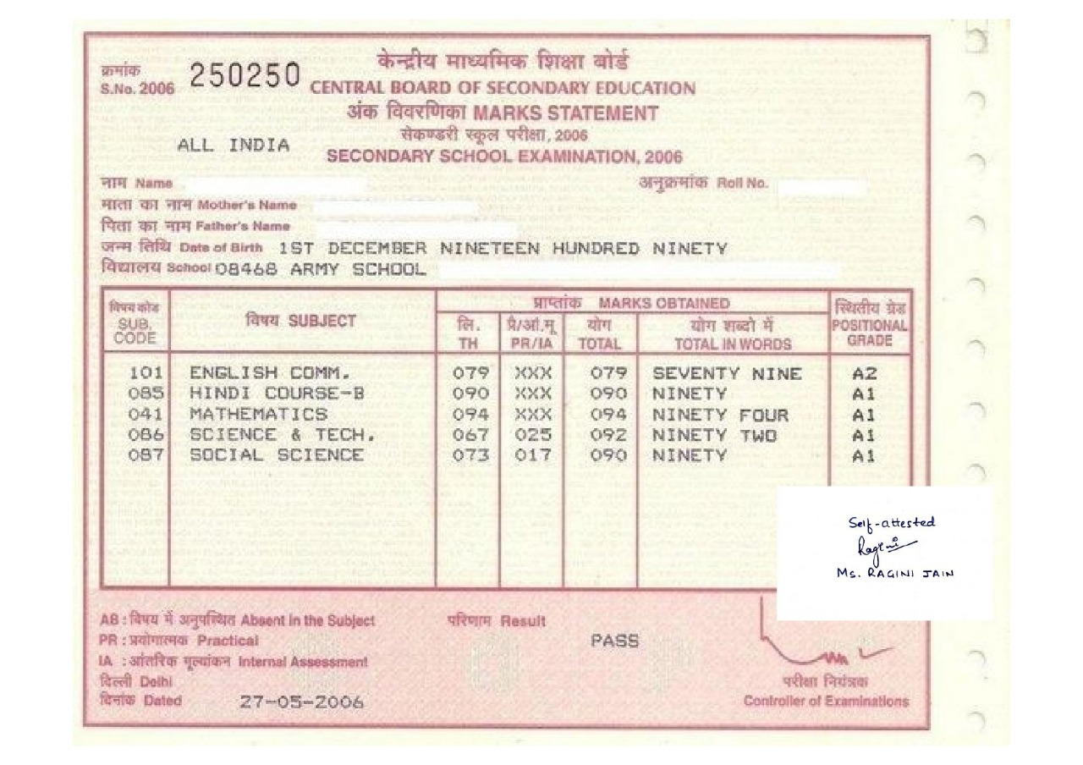
SAMPLE DOCUMENT DEMONSTRATING HOE THE CERTIFICATES ARE TO BE ATTESTED AND SCANNED AND COMPILED IN THE FORMAT REQUIRED.

APPLICATION FORM:

- Full Name in Capital Letters (As per the MatriculationCertificate):
- Gender:
- Date of Birth (As per the MatriculationCertificate):
- Father’s Name (As per the MatriculationCertificate):
- Nationality:
- Post Applied For:
- Permanent Address:
- Address for Communication:
- Mobile number and Email ID (a valid and functional email ID to be provided):
- Academic Qualifications:
QUALIFICATION | NAME AND ADDRESS OF COLLEGE/INSTITUTION | UNIVERSITY | YEAR OF PASSING
10+2
Higher Qualification

- Details of Services rendered earlier/Experience in related field: (After the Basic Graduation).
Post/Designation | Name and Address of the Organization | Duration of Tenure |  | Total Period
 |  | From | To

Declaration: I solemnly declare that the above statements made by me are correct to the best of my knowledge and belief. I shall abide by the rules and regulation of SYS Department, Government of Mizoram/Sports Authority of India.

Name & Signature of Candidate

