File no.D.28012/4/2020-DTE(SYS)
SPORTS AND YOUTH SERVICES DEPARTMENT
GOVERNMENT OF MIZORAM
New capital Complex (MINECO), Khatla, Aizawl, Mizoram-796001

Subject - Notice inviting applications for appointment of STRENGTH & CONDITIONING EXPERT on contract basis for Khelo India State Centres of Excellence, Aizawl, Mizoram.
Sports and Youth Services department, Government of Mizoram &SAI is setting up new sports Academies at Rajiv Gandhi Stadium , Mualpui, Aizawl to nurture the best talent of the country identified through Khelo India Talent Identification. The Academies will be equipped with world class infrastructure and coaching facilities with adequate scientific backup with focused on participation in world sports tournament & Olympics.

In order to lead these High-performance Academies Sports and Youth Services department, Government of Mizoram & Sports Authority of India (SAI), invites applications from eligible citizens of India for filling up the post of one STRENGTH & CONDITIONING EXPERT for Khelo India State Centres of Excellence, Aizawl (Rajiv Gandhi Stadium).The last date for the submission of application is 7th May. 2021.

Sd-
H.LALENGMAWIA
Secretary
Sports and Youth Services Department
Government of Mizoram

STRENGTH & CONDITIONING EXPERT
(Specific requirements, shortlisting and interview information)

- ESSENTIAL EDUCATIONAL QUALIFICATIONS.

Applications are invited from all interested candidates who possess any of the following degree from a recognized Indian or Foreign University and qualification as follows:

- Bachelors or Masters in Sports and Exercise Science/Sports Science/Sports Coaching.

OR

- Any Graduation with ASCA Level-1 or above/CSCS/UK SCA accredited coach/Diploma in fitness training /Certificate course in Fitness Training from Government Institution.

- CRITERIA FOR SHORT LISTING OF CANDIDATES FOR THE INTERVIEW.

Short listing of candidates to provide an optimum ratio for the interview will be carried out on following basis:

CATEGORIES FOR EVALUATION | MAX MARKS | SCORING OF MARKS
Higher Educational Qualifications | 10 | Masters in Sports and Exercise Science/Sports Science - 10 marks | Masters in Sports Coaching –  7marks | Masters in Physical Education/ Diploma in sports coaching– 5marks
Work Experience | 10 | Every completed six months of related experience at a recognized State / National level sports organization(Govt or Private) working with teams/players will be given 1 mark,  Uptoa maximum of 10 marks.
Strength & Conditioning Certification | 15 | ASCA Level 3/CSCS (NSCA)/Level 4 (UK) – 15marks | ASCA Level 2/Level 3 (UK)- 10marks | ASCA Level 1/Certificate course in Strength &Conditioning/ fitness trainer level 4 certification from National Skill Development Cooperation of India – 5marks
Percentage of Marks obtained in Graduation | 5 | ≥50%--<60% =2 marks  ≥60%--<70% =3marks  ≥70%--<80% =4marks  ≥80% =5marks.
Sports achievement | 10 | International Level (Representing India in a sports event recognizedby sports governing bodies)– 10marks | Medal at National Level (Representing his/her state in national competition recognized National Sports Federation) – 7marks | Medal at University/State Level( representing district/universityin a state level, university competition recognized by State Sports body or AIU)– 5marks

- INTERVIEW PROCESS

The interview will be of 100 marks.

The Candidates will be assessed on the following:

CATEGORIES FOR EVALUATION | MAXIMUM MARKS
Domain Expertise | 30
Practical knowledge and knowledge of allied sports science disciplines | 20
Aptitude for working in a sports organization | 15
Principles of training, Programming of training design and its organisation | 15
Soft skills | 10
Pre-Rehabilitation& Injury Management | 10

NOTE:

THE ABOVE MENTIONED SHORT LISTING CRITERIA WILL BE USED FOR CALLING THE CANDIDATES TO APPEAR IN THE INTERVIEW.

THE FINAL MERIT WILL BE BASED ON THE SCORE OBTAINED IN THE INTERVIEW ONLY.

THE CANDIDATE MUST PRODUCE ALL DOCUMENTSIN ORIGINAL, AT THE TIME OF PHYSICAL JOINING OTHERWISE THE CANDIDATURE WILL BE CANCELLED.

GENERAL INSTRUCTIONS

(All the instructions given below must be strictly followed or else the application
is liable to be rejected)

- WHO CAN APPLY :Online applications are invited from Indian citizens both male and female, who are eligible according to Essential Educational Qualification mentioned above on contract basis.

HOW TO APPLY: Eligible candidate shall submit their Application in the format given at Annexure II, by post and email, on or before ______march 2021, 4 PM at following address:-

Directorate of Sports and Youth Services, Government of Mizoram
New Capital Complex (MINECO), Khatla, Aizawl, Mizoram By email- dsysmizoram@gamil.com
- Applications received through any other mode would not be accepted and summarily rejected.
- Before registering /submitting applications on the website the candidates should possess a valid E-mail ID.
- The e-mail ID entered in the online application form should remain active until the recruitment process is completed. No change in the e-mail ID will be entertained.

- DOCUMENTS REQUIRED TO BE UPLOADED

Self attested scanned copy of original documents of the following be uploaded:

- DEGREE AND MARKSHEET :(whichever applicable)

The certificate uploaded must be one issued by the Competent Authority (i.e. University or other examining body) awarding the particular qualification.

- WORK EXPERIENCE

Documents claiming work experience must clearly mention the following

- Name of the establishment.
- Signatureof competent authority/issuing authority clearly stating their position of authority in the organization.
- Duration of work experience.
- The field in which the candidate has worked or the post held in the establishment.

- STRENGTH AND CONDITIONING CERTIFICATIONS (whichever applicable)

- SPORTS ACHIEVEMENTS

Claims of sports achievements are to be supported by appropriate documents.

- IMPORTANT INSTRUCTIONS FOR UPLOADING DOCUMENTS:

Passport Size Photograph and Signatures :

The candidate should scan his photograph and specimen signature in JPG format. The digital size of file should not exceed 300 KB each and must not be less than 20 KB. Minimum resolution of the file should be 350 pixels (Width) X 350 pixels (Height) and maximum 1000 pixels (Width) X 1000 pixels (Height). Bit Depth of image file should be 24 bit.

UPLOADING OF DOCUMENTS: After the initial registration is completed online, the following essential certificates/ documents should be self attested, scanned and uploaded strictly in the order mentioned below. All these documents should be compiled in a single pdf file and uploaded by clicking on the upload documents button.

a) Candidate details: Name
              - Application No
              - Contact No
              - Address
              - Email id
- Document for DOB:
- Bachelor’s degree and Marksheet.
- Masters degree
- Work experience Certificate.
- S& C certifications.
- Certificate claiming sports achievement
- No Objection Certificate from present employer, if any.

NOTE: Non self-attested documents will be rejected.

IN CASE OF ANY PROBLEM FACED IN APPLYING ONLINE, PLEASE CONTACT AT TELE NO. 011- 24367771 ONLY DURING OFFICE HOURS(10:00 AM-12:00 PM) ON WORKING DAYS.

- CANDIDATES SHOULD CHECK THE WEBSITE AND THEIR REGISTERED EMAIL REGULARLY FOR UPDATES REGARDING INTERVIEW DATES AND OTHER RELEVANT DETAILS. ANY VARIATION IN THE DETAILS PROVIDED AND DOCUMENTS SUBMITTED ONLINE WILL LEAD TO REJECTION OF THE CANDIDATE. ANY UPDATES AND NOTIFICATIONS WILL BE HOSTED ON THE WEBSITE.

- CALL LETTERS FOR INTERVIEW: The Call Letters for interview shall be communicated electronically in the valid and functional email id provided by the candidate during online registration.

- The responsibility of ensuring genuineness of the certificate lies completely with the candidate by self-attestation. SYS Department, Government of Mizoram reserves the right to discard experience certificates which do not provide correct details as asked above. Website links could be provided to ascertain genuineness.

- Any experience claimed during the course of completion of the degree will not be counted. Any experience which is not relevant to the above discipline /fields will not be counted.

- Candidates will be called for the interview based on the shortlisting criteria as mentioned above. Hence mere fulfillment of eligibility criteria does not entail that candidate will be called for the interview.

- The Candidates should note that their candidature at all the stages will be purely provisional, subject to their satisfying the prescribed eligibility conditions. If on verification at any stage before or after Interview, it is found that they do not fulfill any of the eligibility conditions; their candidature will be cancelled by the SYS Department, Government of Mizoram.

- NOTE: SELECTED CANDIDATES WILL BE REQUIRED TO PRODUCE THE ORIGINALS OF THE CERTIFICATES MENTIONED ABOVE AT THE TIME OF JOINING. FAILURE TO SUBMIT THE REQUIRED CERTIFICATES IN ORIGINAL AT THE TIME OF PHYSICAL JOINING WILL LEAD TO CANCELLATION OF CANDIDATURE.

- Terms & Conditions for contractual engagement:

- Tenure:Initial contractual engagement will be for a period of three years. The tenure can be further extended by two years for a maximum period of five years on the basis of satisfactory performance. The tenure is subject to continuation of Khelo India Scheme.

- Age limit:The candidate must not have attained 45 years of age as on the closing date for the advertisement.
The date of birth, accepted by the SYS Department, Government of Mizoram is that entered in the Matriculation or Secondary School Leaving Certificate or in a certificate recognized by an Indian University as equivalent to Matriculation or in an extract from a Register of Matriculates maintained by a University which extract must be certified by the proper authority of the University or in the Higher Secondary or an equivalent examination certificate. Aadhar Card/Passport/Voter Id will also be accepted. No other document relating to age like horoscopes, affidavits, birth extracts from Municipal Corporation, Service records and the like will be accepted. The expression Matriculation/Higher Secondary Examination Certificate in this part of the Instruction include the alternative certificates mentioned above.
.

- Remuneration: - Monthly remuneration will be decided on the basis of expertise and performance of the candidates in the interview and on the recommendation of the Selection Board. Based on the recommendation , the candidates will be placed in two grades (Grade I and Grade II) as follows:

DESIGNATION | GRADE | REMUNERATION
Strength And Conditioning Expert | Lead | Rs. 60,000- 80,000/-

- Tax Deduction at source: - The income tax or any other tax liable to be deducted, as per the prevailing rules will be deducted at source before effecting the payment, for which the SAI will issue TDS certificates/ Service Tax, as applicable.

- Other Allowances: - No TA /DA shall be admissible for joining the assignment or on its completion. No other facilities like DA, Accommodation, Residential Phone, Conveyance /Transport, Personal Staff, Medical reimbursement, HRA, and LTC etc. would be admissible to them. In case he/she is required to proceed outstation from place of posting for official duty, he/she will be entitled to TA/DA as per Level Pay Level 10 under GOI rules.

- Extension: - Performance of the selected candidates would be continuously reviewed and their extension will be considered on the basis of periodic review /requirements.

- Leave: - Personnel will be entitled for 30 days leave in a calendar year on pro- rata basis. Employee shall not draw any remuneration in case of his/her absence beyond 30 days in a year. Also any un-availed leave in a calendar year will lapse and will not be carried forward to the next calendar year.

- Termination:- The contract can be terminated by giving a 30 days’ Notice period by either party, ie. SAI and the employee. In cases of extreme impropriety by the employee the contract may be terminated immediately without notice.

- Candidates must apply within the scheduled time period, no application received after the last date shall be entertained.

- Candidates who apply under this advertisement may also be shortlisted for future requirements of Sports Science support staff in organisations covered under KheloIndia Schemes.

- Decision of SYS Department, Government of Mizoram in all matters regarding eligibility, selection and posting would be final and binding on all candidates. No representation or correspondence will be entertained by SYS Department, Government of Mizoram in this regard.

- SYS Department, Government of Mizoram reserves the right to modify/alter/restrict/enlarge/cancel the recruitment process, if need so arises without issuing any further notice or assigning any further notice/any reasons thereafter. The decision of the SYS Department, Government of Mizoram will be final and no appeal will be entertained against this issue. The panel made by SYS Department, Government of Mizoram can also be utilized by various other Govt. organization which are supported under various schemes of SAI / Ministry of Youth Affairs & Sports.

- In case of any dispute, jurisdiction of Court at Mizoram only will be applicable.

- Please do visit your email account regularly for further updates.

- Further notifications/corrigendum in this regard, if any, will be put up on SYS Department, Government of Mizoram website only(www.sys.mizoram.gov.in).

- In case of any dispute, English version of the Employment notice will be treated as valid.

CANVASSING IN ANY FORM WILL BE A DISQUALIFICATION.

Designation | Job Responsibilities
Strength & Conditioning Expert | - Design and implement strength training and conditioning programs in-season, off-season, and pre-season for all athletes in various programs in a manner that reflects research-driven practices in accordance with the Long-Term Athletic/Fitness Development Model.  - Work in cooperation with the sports medicine or athletic training staff in the rehabilitation and strengthening of injured athletes.  - Facilitate a collaborative relationship among sport coaches, sports medicine, and the strength and conditioning staff.  - Design and implement policies and procedures for the strength and conditioning program in accordance with the guidelines of SYS Department, Government of Mizoram.  - Develop systems for tracking athlete attendance and athlete progress in conjunction with the sport coaches.  - Conduct an annual needs-analysis for each sport team in conjunction with the Coaching staff and sport science team at the conclusion of each sport season.  - Annually conduct and review a departmental risk management plan.  - Complete an annual budgetary proposal for the program that includes routine maintenance, purchase of new equipment, and staffing needs.  - Determine and reinforce expectations for athlete conduct for curricula and extra-curricular activities, as stated in the Centers Athlete Code of Conduct.  - Conduct an annual evaluation including the design of professional development activities.  - Carry out research on newest methods and techniques in Strength & Conditioning domain.  - Analyze data collected from athletes to suggest formation of norms for Indian athletes.  - Actively enter all data needed in the Athlete management System or with respect to performance evaluation of athletes.  - Any other duties assigned by High Performance Director, Sports Science Head and Regional Head and Director General SYS Department, Government of Mizoram.

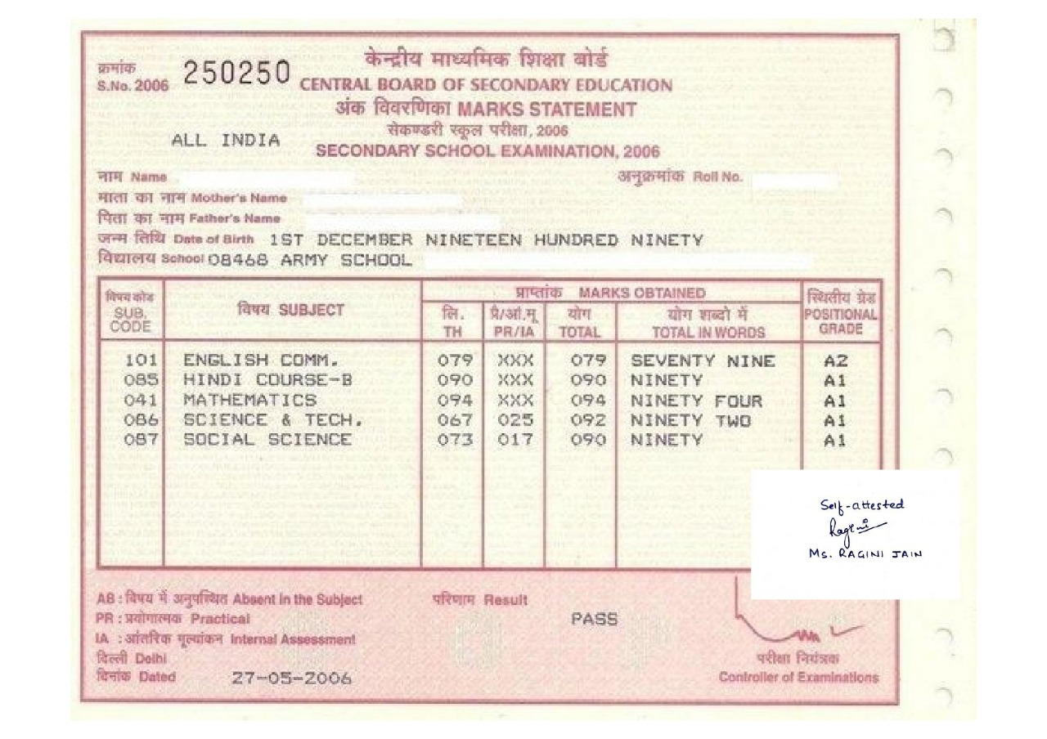

SAMPLE DOCUMENT DEMONSTRATING HOE THE CERTIFICATES ARE TO BE ATTESTED AND SCANNED AND COMPILED IN THE FORMAT REQUIRED.

APPLICATION FORM:
APPLICATION FORM FOR THE POST OF STRENGTH & CONDITIONING EXPERT
- Full Name in Capital Letters (as per the matriculation certificate):
- Gender:
- Date of Birth (as per the matriculation certificate):
- Father’s Name (as per the matriculation certificate):
- Nationality:
- Post Applied For:
- Permanent Address:
- Address for Communication:
- Mobile number and Email ID (a valid and functional email ID to be provided):
- Academic Qualifications:

Degree | Maximum Marks | Marks Obtained | Percentage of Marks | Name and Address of College/Institution | University | Year of Passing
Graduation (specify the discipline)
Post-Graduation(specify the specialty)

- Details of S & C certification course whichever applicable.
- Details of Services rendered earlier/Experience in related field: (After the basic graduation).
Designation | Name and Address of the Organization | Duration of Tenure |  | Total Period
 |  | From | To
- Details of sports achievements- Details of participation- Name of event.
Year of participation
Position
Declaration: I solemnly declare that the above statements made by me are correct to the best of my knowledge and belief. I shall abide by the rules and regulation of Sports Authority of India.

Name & Signature of Candidate

